***BE 1600***

***Introduction to***

***Programming and Computation***

***Python***

**Assignment 02**

40 points

**Due 09/27/2023 (11:45 A.M.)**

Assignment Objectives:

* To write Boolean expressions using relational operators .
* To implement selection control using one-way if statements .
* To implement selection control using two-way if-else statements .
* To implement selection control with multi-way if-elif-else statements.
* To program with selection statements .
* To combine conditions using logical operators (and, or, and not).
* To understand the rules governing operator precedence and associativity.

*Solution for this assignment will not be posted on Canvas; however, the solution of any of the assignment problems can be discussed in the class upon request of a student.*

All assignments must be submitted by the Canvas. **No email or hard copy** is accepted. You must follow the following format:

1. For non-programming questions, use a word file to type your answers. Don’t use the text box on the Canvas to answer the questions or to write comments, we will not read it. State your answer clearly.
2. For programming questions, include only the source file of each programming problem.
3. Submit your files to the Canvas. You must submit your files on time; otherwise, you will receive zero.
4. Use “Add Another File” feature on Canvas to upload each additional file; do not upload the files as a compressed folder.
5. You can upload your files as many times as you like. Only the last attempt counts because the last files you uploaded are the only files your instructor will see.
6. There will be several modules on the Canvas. You need to upload your files using the correct module on the Canvas.
7. Name each file: *Assignment (assignment number)* for the word file [e.g. Assignment 02] and *Assignment (assignment number) _ (Question number)* for each programming question [e.g. Assignment 02_Q03].
8. To upload your file(s):

* In Course Navigation, click the ASSIGNMENTS module.
* Click the title of the assignment.
* Click the **Submit** Assignment button.
* Add **File**. ...
* Add Another **File**. ...
* **Submit** Assignment. ...
* View **Submission**.

*It is your responsibility to make sure that each file is uploaded correctly. If you uploaded a wrong file, you receive zero; files will not be accepted after due date even if you have a prove that the file is created before the due date.*

***Make sure you review the Cheating & Plagiarism policy on Canvas.***

Write a program for questions Q.1. to Q.7. Convert each .py to a text file. Submit 7 files (.txt files) to Canvas by the due date.

**Question 01 (5 points)**

Write a program that creates integers x, y, and z. The program uses the three values to determines if each of the following expressions is True or False.

1. x + 6 == 3 + y
2. 2 * 6 - 4 >= 9 - z
3. 6 // y < 3 - 1
4. 18 // x == 2 * 3
5. not(x - y >= 1)
6. z <= 7 or y < 12
7. (x + y != 40) and (x != z)
8. (z - x >= y) or (y - x != z + 4)
9. (5 - x <= 2 * y) and (y -15 >= z) or (x - 5 != y - 2 * z)
10. (True and False) or not (False or False)

Note: try to evaluate the expressions before you run the code.

Here is a sample run:

**x = 27**

**y = 24**

**z = 19**

**A: x + 6 == 3 + y -> False**

**B: 2 * 6 - 4 >= 9 - z -> True**

**C: 6 // y < 3 - 1 -> True**

**D: 18 // x == 2 * 3 -> False**

**E: not(x - y >= 1) -> False**

**F: z <= 7 or y < 12 -> False**

**G: (x + y != 40) and (x != z) -> True**

**H: (z - x >= y) or (y - x != z + 4) -> True**

**I: (5 - x <= 2 * y) and (y -15 >= z)or (x - 5 != y - 2 * z) -> True**

**J: (True and False) or not (False or False) -> True**

**Question 02 (5 points)**

Suppose you shop for rice and find it in two different sized packages. You would like to write a program to compare the costs of the packages. The program prompts the user to enter the weight and price of each package and then displays the one with the better price or if both packages have the same price. Use only one-way selection statement.

Here are sample runs:

Enter weight for package 1: 2.5

Enter price for package 1: 5.50

Enter weight for package 2: 3.25

Enter price for package 2: 3.50

Package 2 has the best price.

Enter weight for package 1: 10.50

Enter price for package 1: 6.50

Enter weight for package 2: 4.50

Enter price for package 2: 10.50

Package 1 has the best price.

Enter weight for package 1: 6.0

Enter price for package 1: 2.0

Enter weight for package 2: 12.0

Enter price for package 2: 4.0

Package 1 and Package 2 have the same price.

**Question 03 (5 points)**

Write a program that prompts the user to enter an integer and checks whether the number is divisible by both **5** and **6**, divisible by just one of them (but not both), and not divisible by either one.

Here are four sample runs:

Enter an integer: 30

30 is divisible by both 5 and 6

Enter an integer: 35

35 is divisible by 5 or 6, but not both

Enter an integer: 36

36 is divisible by 5 or 6, but not both

Enter an integer: 37

37 is not divisible by either 5 or 6

**Question 04 (5 points)**

Write a program that prompt a user to enter a Head or a Tail; the program prompts second user to guess whether first user entered a Head or a Tail. The program reports whether the second user guess is correct or incorrect.

Here are two sample runs:

User 01: Enter Head or Tail: Head

User 02: head or tail? Head

Head is the correct guess

User 01: Enter Head or Tail: Head

User 02: head or tail? Tail

Sorry, it is a head

User 01: Enter Head or Tail: Tail

User 02: head or tail? Tail

Tail is the correct guess

User 01: Enter Head or Tail: Tail

User 02: head or tail? Head

Sorry, it is a tail

**Question 05 (5 points)**

Write a program that prompts the user to enter the center coordinates and radius of two circles and determines whether the second circle is inside the first or overlaps with the first, as shown in the below figure.

(Hint: circle2 is inside circle1 if the **distance between the two centers + r2 <= r1** and circle2 overlaps circle1 if the **distance between the two centers <= r1 + r2**.

Test your program to cover all cases.)

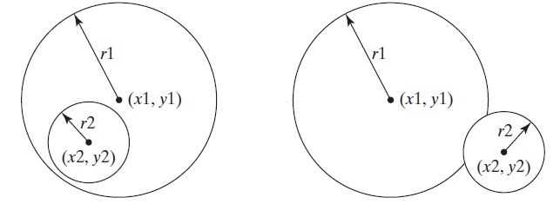

Sample three runs:

Enter circle1's center x coordinate: 0.5

Enter circle1's center y-coordinates: 5.1

Enter circle1's radius: 13

Enter circle2's center x coordinate: 1.0

Enter circle2's center y-coordinates: 1.7

Enter circle2's radius: 4.5

circle2 is inside circle1

Enter circle1's center x coordinate: 4.4

Enter circle1's center y-coordinates: 5.7

Enter circle1's radius: 5.5

Enter circle2's center x coordinate: 6.7

Enter circle2's center y-coordinates: 3.5

Enter circle2's radius: 3

circle2 overlaps circle1

Enter circle1's center x coordinate: 4.4

Enter circle1's center y-coordinates: 5.5

Enter circle1's radius: 1

Enter circle2's center x coordinate: 5.5

Enter circle2's center y-coordinates: 7.2

Enter circle2's radius: 1

circle2 does not overlap circle1

**Question 06 (7 points)**

Given a directed line from point p0(x0, y0) to p1(x1, y1), you can use the following condition to decide whether a point p2(x2, y2) is on the left side of the line, on the right side of the line, or on the same line (see the below Figure)

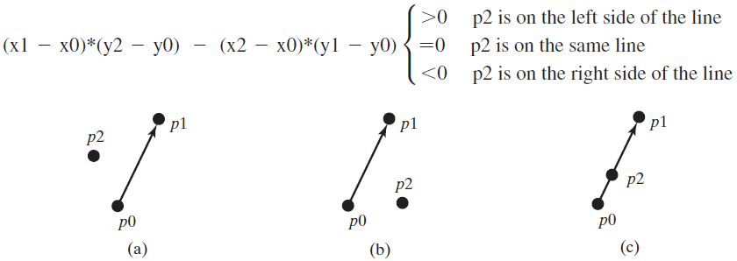

Write a program that prompts the user to enter the x- and y-coordinates for the three points p0, p1, and p2, and displays a message to indicate whether p2 is on the left side, the right side, or on the line from p0 to p1. Display the three points using turtle library, as shown in the below sample runs.

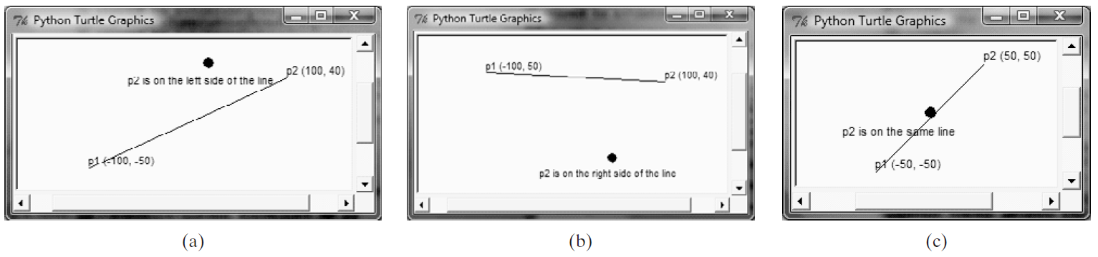

**Question 07 (8 points)**

Write a program that mimics a calculator. The program should take as input two integers and the operation to be performed. It should then output the numbers, the operator, and the result. (For division, if the denominator is zero, output an appropriate message. If illegal operation entered, output an appropriate message).

Here are sample runs:

Enter first integer: 3

Enter second integer: 4

Enter operator (+ - * /): +

3 + 4 = 7

Enter first integer: 6

Enter second integer: 2

Enter operator(+ - * /): -

6 - 2 = 4

Enter first integer: 5

Enter second integer: 7

Enter operator(+ - * /): *

5 * 7 = 35

Enter first integer: 8

Enter second integer: 2

Enter operator (+ - * /): /

8 / 2 = 4.0

Enter first integer: 8

Enter second integer: 0

Enter operator(+ - * /): /

8 / 0 = ERROR: Cannot divide by zero

Enter first integer: 5

Enter second integer: 6

Enter operator (+ - * /): $

5 $ 6 = Illegal operation